**MINT Speciality Dental Clinic**

Mint Speciality Dental Clinic, located near Reliance Petrol Pump beside the Rahul Gandhi Office in Kalpetta North, Wayanad, is a modern dental care facility offering a range of specialized services. The clinic focuses on delivering high-quality dental treatments, with an emphasis on patient care and comfort. It is easily accessible due to its prime location in a well-known area.

The clinic offers services in both general and cosmetic dentistry, likely utilizing advanced dental technologies and techniques. Patients can book appointments online through platforms like JustDial, adding to the clinic's convenience and accessibility. The clinic's presence on JustDial indicates a commitment to reaching a broader audience while maintaining high standards of care.

With skilled staff and a professional approach, Mint Speciality Dental Clinic is positioned to cater to the dental needs of both locals and visitors, ensuring a comprehensive, patient-centered dental experience.

**Strengths**

* Convenient location near a major landmark (Reliance Petrol Pump, Kalpetta).
* Specialization in dental care, which may attract customers seeking focused expertise.
* Clinic’s specialization in dental services, focusing on quality care.
* Likely positive word-of-mouth and local reputation, as clinics in small towns often rely on customer loyalty.

**Weaknesses**

* Limited brand awareness outside Wayanad due to local focus.
* Potential competition from larger or multi-specialty clinics.
* Limited reach beyond Wayanad, especially if there’s minimal digital marketing presence.
* Reliance on local clients, which can cap revenue potential.

**Opportunities**

* Expansion into advanced dental procedures and aesthetic dentistry could attract new clientele.
* Collaborations with local businesses or tourism (Wayanad being a tourist destination) can boost patient numbers.
* Leverage digital platforms (social media, Google reviews) to enhance visibility and reputation.

**Threats**

* Competitive pricing from larger or more established dental chains in nearby cities.
* Economic fluctuations in the region could impact patients’ willingness to spend on non-essential dental services.
* Emergence of tele-dentistry and remote consultations, offering convenience without a physical visit.

**Competitor’s**

**1.Dental Care Clinic, Kalpetta**

**Services Offered**

* General dentistry, pediatric care, and cosmetic dentistry, similar to Mint Speciality.
* May have a more established client base due to longevity.

**Strengths**

* Strong word-of-mouth reputation, likely being an older player.
* Possibly offers competitive pricing due to local familiarity.

**Weaknesses**

* Potential lack of specialization in advanced procedures.
* Limited online visibility and branding compared to newer clinics.

**Comparison With Mint Speciality**

* Mint can leverage its niche as a specialized clinic, offering advanced technology and services to differentiate.
* Mint can outpace the competitor by boosting digital presence, using SEO and targeted marketing campaigns to attract customers seeking modern and specialized dental care

**2.Smile Dental Clinic, Mananthavady**

**Services Offered**

* General dentistry, orthodontics, and restorative dental care.
* Family-focused, offering preventive care for children and adults alike.

**Strengths**

* Established local presence with strong community ties.
* Emphasis on preventive care and family dentistry, appealing to long-term clients.

**Weaknesses**

* May lack advanced equipment or specialization in cosmetic procedures.
* Limited online presence or digital marketing, relying more on local word-of-mouth.

**Comparison With Mint Speciality**

* Mint can differentiate by offering more specialized treatments like cosmetic dentistry and advanced technology.
* Mint's focus on leveraging digital platforms can attract a broader audience, especially those seeking modern services.

**Overview**

The objective of this marketing proposal is to elevate Mint Specialty Dental Clinic’s digital presence in Wayanad, attract new patients, and build brand awareness using Google Ads and social media platforms. The proposal outlines an integrated approach combining Google Ads, Facebook, and Instagram Ads to maximize reach, engagement, and conversions.

**Objectives**

1. **Increase Brand Awareness:** Establish Mint Speciality Dental Clinic as a leading dental provider in Wayanad.
2. **Drive Traffic to the Clinic:** Attract new patients through targeted campaigns and increase website visits.
3. **Enhance Patient Retention:** Boost patient retention through loyalty programs, and engagement activities.
4. **Improve Online Presence:** Rank in the top 3 Google search results for "dentist in Wayanad" and similar queries.
5. **Create Community Engagement:** Build a loyal community through content and social media marketing.

**Target Audience**

**Primary Audience**

1. **Local Residents (Wayanad)**: Families, working professionals, and senior citizens in need of general and specialized dental care.
2. **Tourists & Expats**: Tourists visiting Wayanad for eco-tourism, particularly those interested in dental tourism.

**Secondary Audience**

1. **Schools and Corporates**: For corporate dental care plans and educational dental health programs.
2. **Referrals from General Practitioners and Other Dentists**: Create referral networks with local healthcare providers.

**Marketing Strategies**

**1. Google Ads Campaign**

Google Ads will target people actively searching for dental services. We'll focus on location-based searches to capture the local audience and drive more patients to the clinic.

**Target Audience**

**Primary Audience**

1. **Local Residents (Wayanad)**: Families, working professionals, and senior citizens in need of general and specialized dental care.
2. **Tourists & Expats**: Tourists visiting Wayanad for eco-tourism, particularly those interested in dental tourism.

**Secondary Audience**

1. **Schools and Corporates**: For corporate dental care plans and educational dental health programs.
2. **Referrals from General Practitioners and Other Dentists**: Create referral networks with local healthcare providers.

**1.1 Campaign Types**

* **Search Campaigns**: Show ads to users searching for dental services (e.g., "dentist in Wayanad," "dental implants Wayanad").

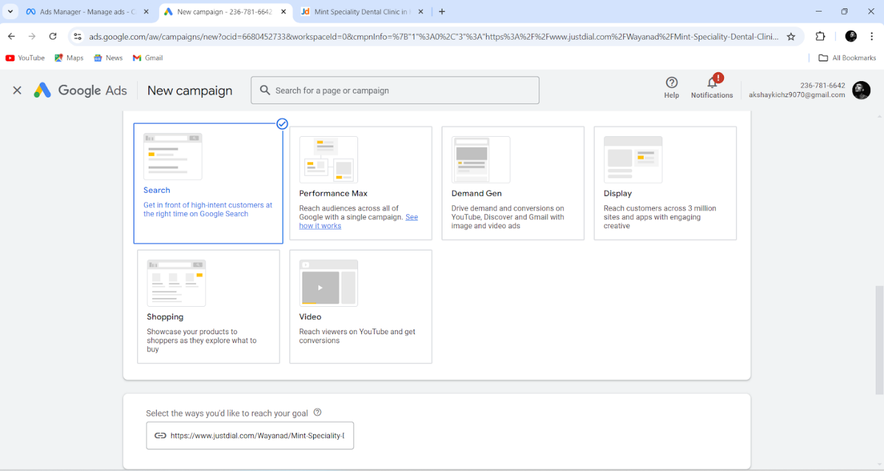

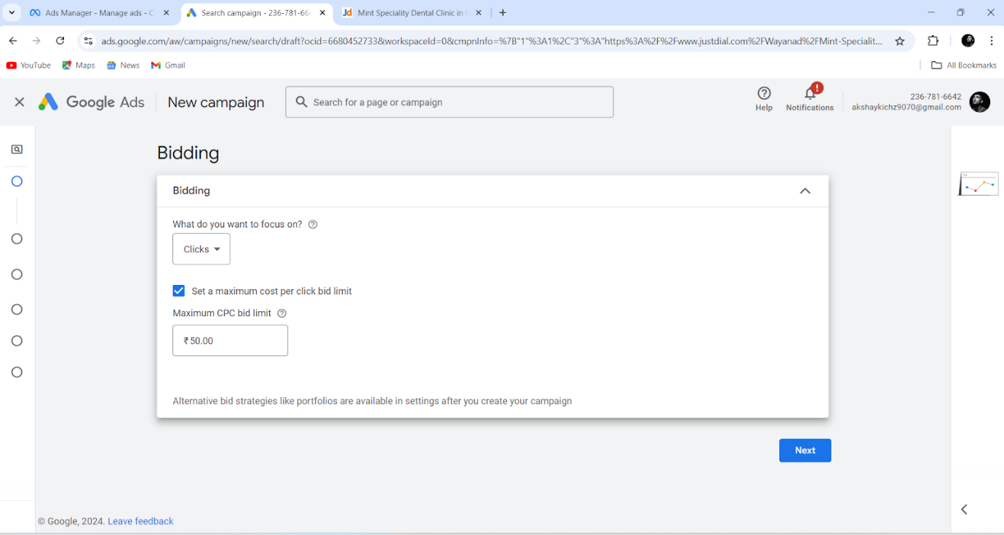

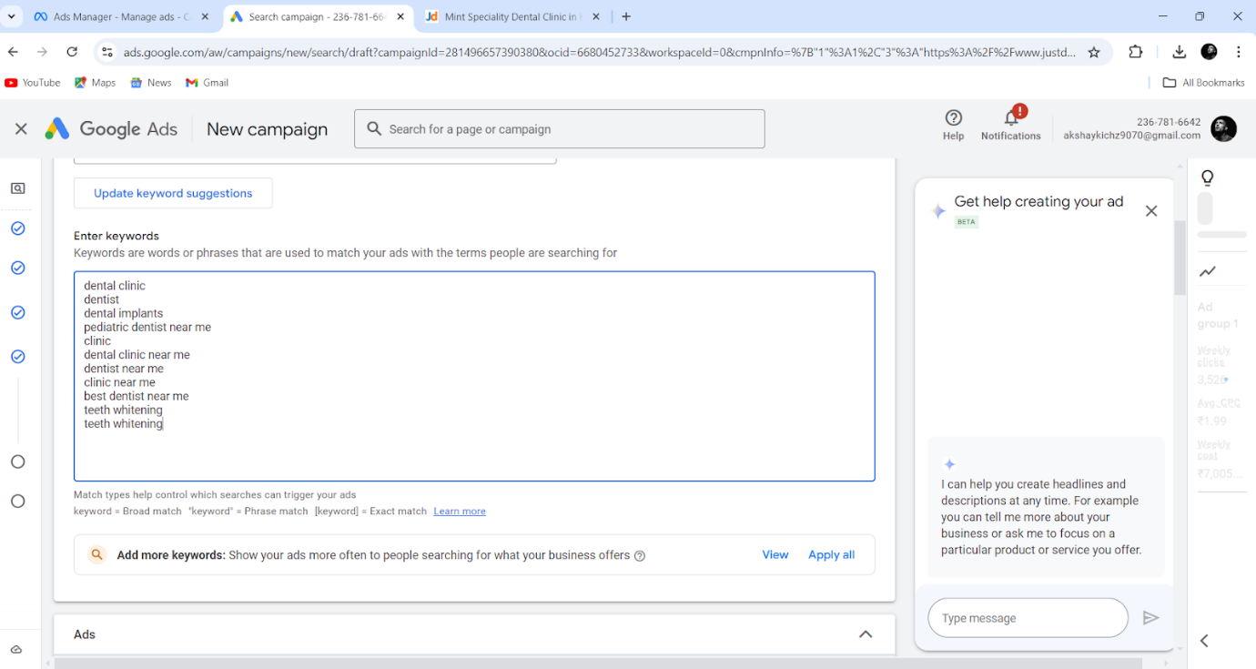

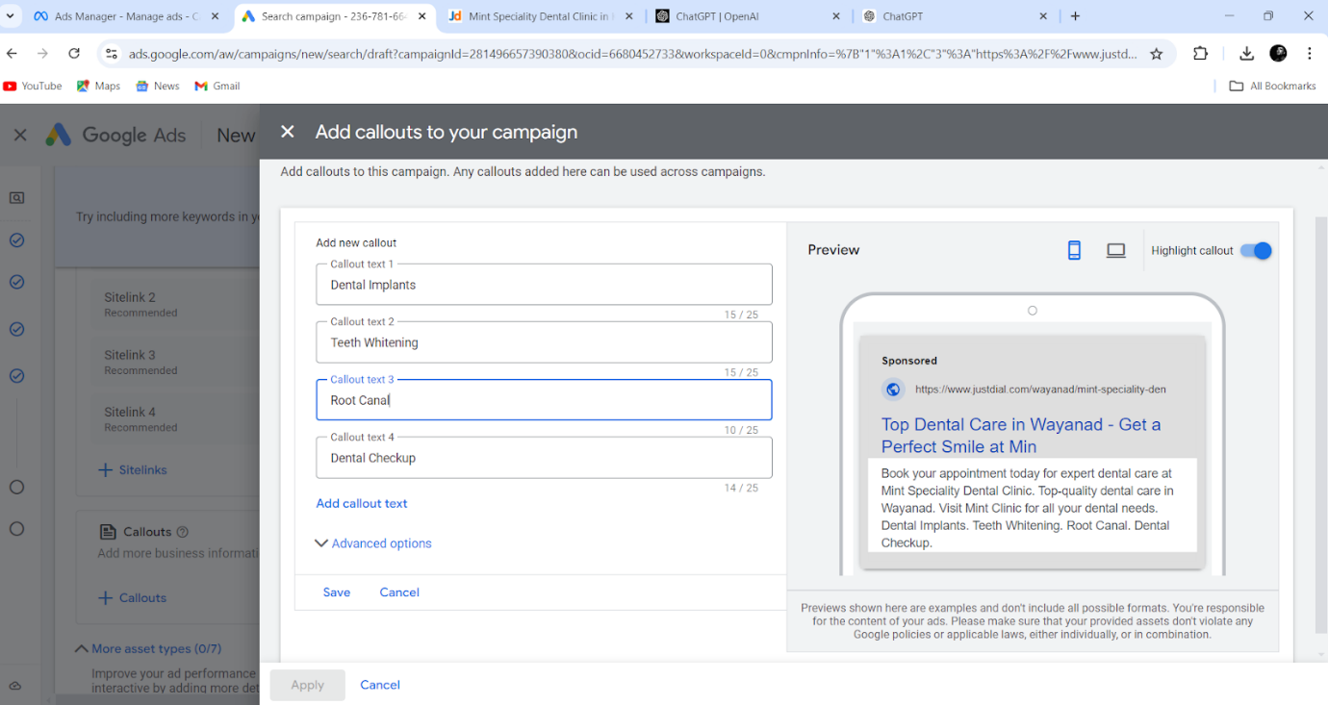

* **Display Campaigns**: Visual banners on relevant websites to build brand awareness.

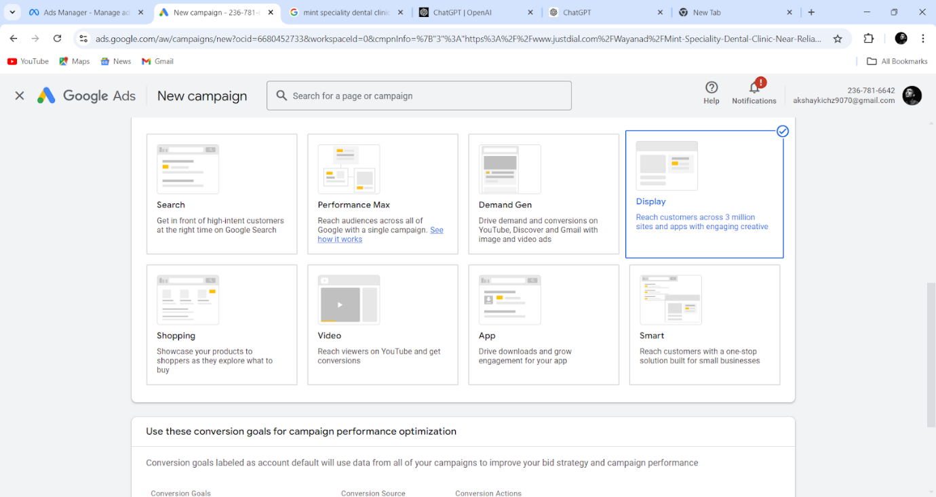

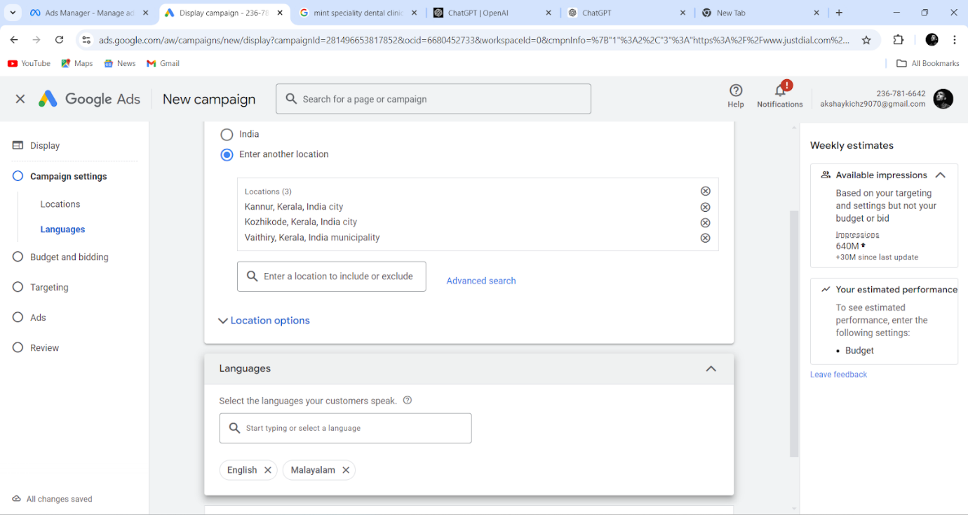

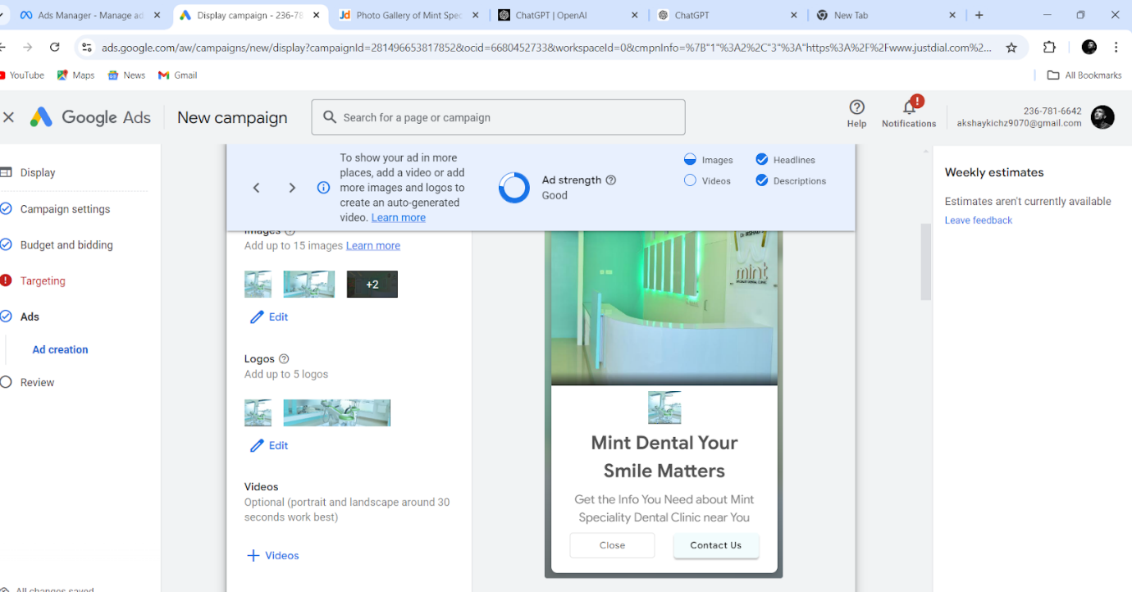

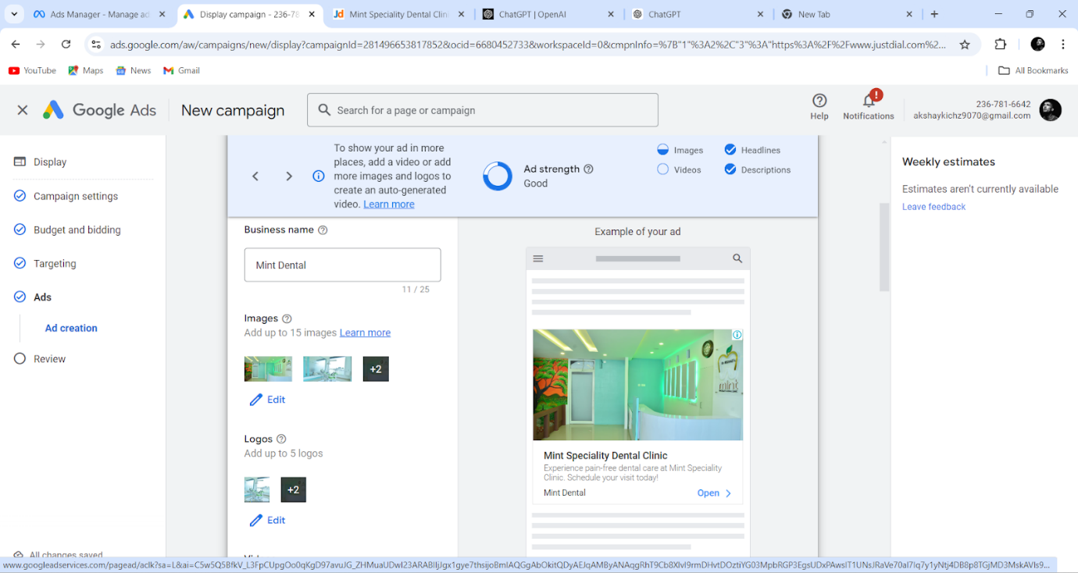

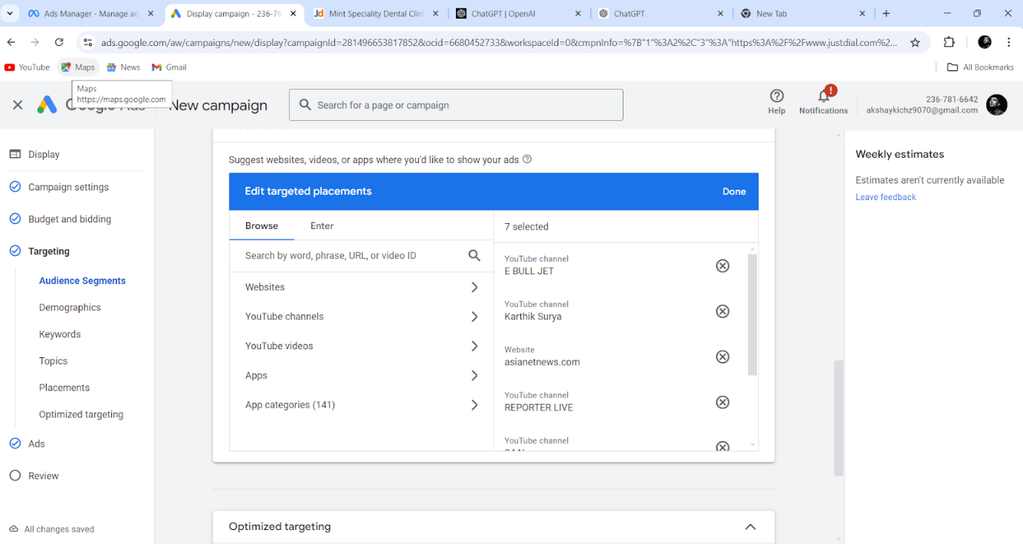

**1.2 Keyword Strategy**

* **Keywords**:
  + Dentist in Wayanad
  + Dental clinic
  + Best dental clinic
  + Best dental clinic in Wayanad
  + Dental implants
  + Orthodontics in Wayanad
  + Pediatric dentist near me
  + Teeth whitening
  + Root canal treatment
  + Dentist near me
  + Dental surgery

**1.3 Ad Copy**

We will create engaging and relevant ad copies that include

* **Emotional Triggers**: Emphasizing pain-free treatments and patient comfort.
* **Offers**: Special promotions such as "Free Consultation" or "10% Off First Visit." Free dental check-up.
* **Call-to-Action**: Strong CTAs like “Contact Us” or “Book Now”

**1.4 Budget & Bidding**

* **Daily Budget**: ₹1,000 – ₹3,000 (adjustable based on performance).
* **Bidding Strategy**: Maximum cost per click for search campaigns and display campaigns.

**2. Social Media Ads Campaign (Facebook & Instagram)**

Social media platforms like Facebook and Instagram are ideal for engaging with potential patients through educational content and promotions, and for building the clinic’s brand image.

**2.1 Target Audience**

* **Demographics**: Age 25-60, both genders, within Wayanad and surrounding areas.
* **Interests**: Health, dental care, family wellness, and beauty.

**2.2 Content Strategy**

* **Engaging Visuals**: High-quality images and videos of the clinic, testimonials, and before-and-after pictures.
* **Educational Posts**: Information on dental health, tips for oral hygiene, the importance of routine check-ups, and new treatments.
* **Promotional Ads**: Featuring offers like discounts on dental cleaning, teeth whitening, or family dental check-up packages.

**2.3 Ad Types**

* **Image and Carousel Ads**: Showcase dental services like implants, cosmetic dentistry, or orthodontics.
* **Video Ads**: Highlighting patient experiences, new technology in the clinic, or a virtual tour of the clinic.
* **Story Ads**: Short, engaging, and direct ads focusing on special promotions or quick tips.
* **Ad Scheduling**: Ads will run during peak browsing times (morning and evening).

**2.4 A/B Testing**

A/B testing (also called split testing) allows us to compare two or more versions of an ad to see which performs better. This ensures we continually refine the strategy based on real-time data and insights.

* **Ad Creatives**:
  + Version 1: Image-based ads (e.g., before-and-after dental transformations, clinic interiors).
  + Version 2: Video ads (e.g., patient testimonials, dentist tips, or virtual clinic tours).
* **Ad Copy**:
  + Version 1: Short, direct copy focusing on promotions (e.g., "Get 10% off your first visit").
  + Version 2: Informative copy emphasizing expertise and patient care (e.g., "Wayanad's Trusted Dental Care").
* **Call-to-Actions**
  + Version 1: "Book Your Appointment Now"
  + Version 2: "Schedule a Free Consultation"
* **Audience Segmentation**:
  + Version 1: Targeting specific interests (e.g., health and wellness, beauty, family care).
  + Version 2: Broad audience based on location only.

**2.5 Optimization Process**

Optimizing social media ads involves continuously tweaking elements to improve performance. We will employ the following methods:

**1 Audience Refinement**

* **Lookalike Audiences**: Based on the data from our initial ads, we will create lookalike audiences to target individuals with similar characteristics as those who already converted.
* **Retargeting Audiences**: We'll retarget people who visited the website or engaged with the clinic's social media pages but haven’t booked an appointment.

**2 Ad Schedule Optimization**

* **Peak Time Analysis**: By reviewing engagement times, we will adjust ad scheduling to maximize visibility during peak times (morning and evening when people are more active on social media).
* **Dayparting**: We may experiment with running ads on specific days of the week based on audience behavior.

**3 Bid and Budget Adjustments**

* **Bid Optimization**: We will use automatic and manual bidding strategies to adjust cost-per-click (CPC) based on ad performance. If the CPC is too high and not converting, we will lower the bids and reallocate the budget to better-performing ads.
* **Budget Shifts**: We will increase the budget for the top-performing ads and reduce spend on ads with lower engagement or conversions.

**2.6 Monitoring Process for Social Media Ads**

Regular monitoring ensures that our campaigns are on track and helps identify any need for adjustments. Our monitoring plan includes real-time tracking and reporting for continuous improvement.

**1 Daily Monitoring**

* **Engagement Metrics**: We’ll keep track of likes, shares, comments, and interactions to measure how well the content resonates with the audience.
* **Click-Through Rate (CTR)**: Review the percentage of people who click on the ad to visit the website or landing page.
* **Cost Per Click (CPC)**: Regularly track the cost per each click and make adjustments to maximize value.

**2 Weekly Reviews**

* **Conversion Rate**: Analyze how many ad clicks resulted in actual bookings or lead form submissions.
* **Audience Insights**: Use Facebook’s audience insights tool to better understand the demographic and interests of people engaging with the ads.
* **Ad Performance Comparison**: Compare all ad sets to understand which creative, audience, or copy is driving better results and allocate more budget to those ads.

**3 Monthly Reporting**

* **Comprehensive Reports**: We will generate detailed reports showing impressions, clicks, CPC, conversions, and overall ROI.
* **Actionable Insights**: Based on the performance data, we’ll provide actionable insights and recommendations for the next month’s campaign adjustments.
* **Goal Tracking**: We'll regularly assess whether we’re on track to meet goals like increasing appointments, building brand awareness, or improving patient engagement.

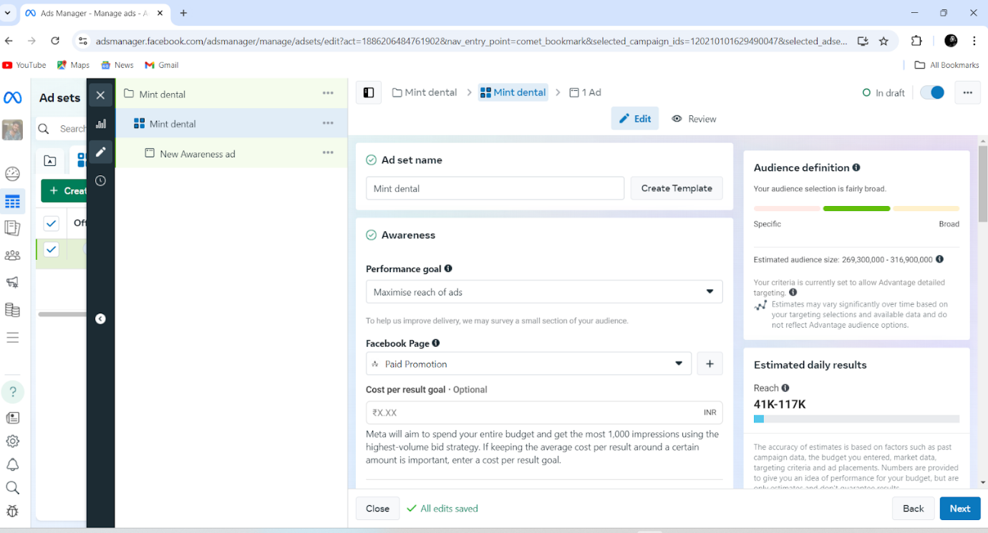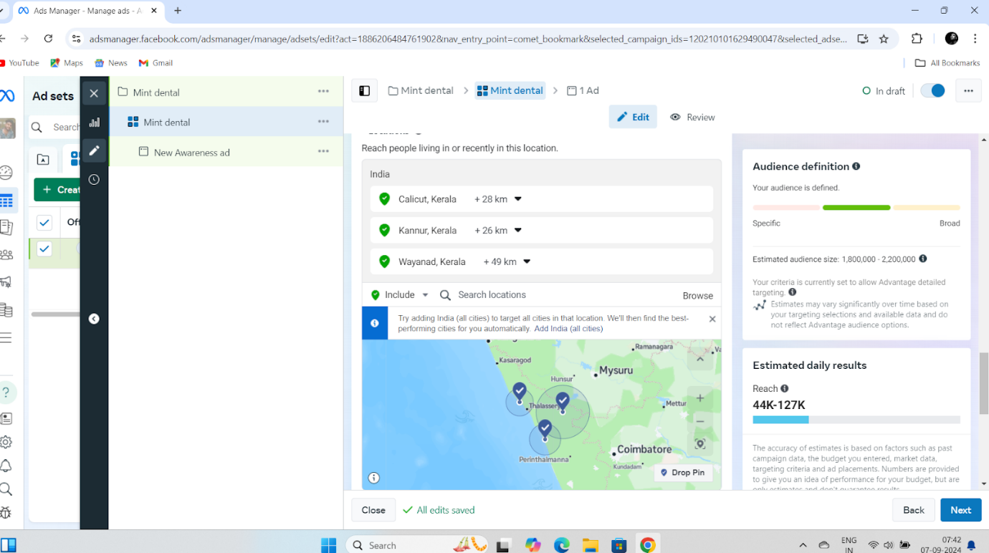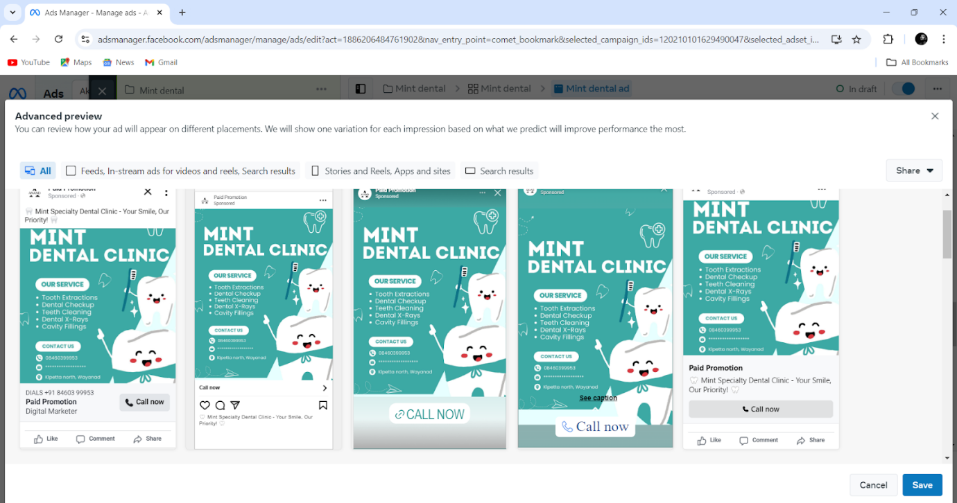

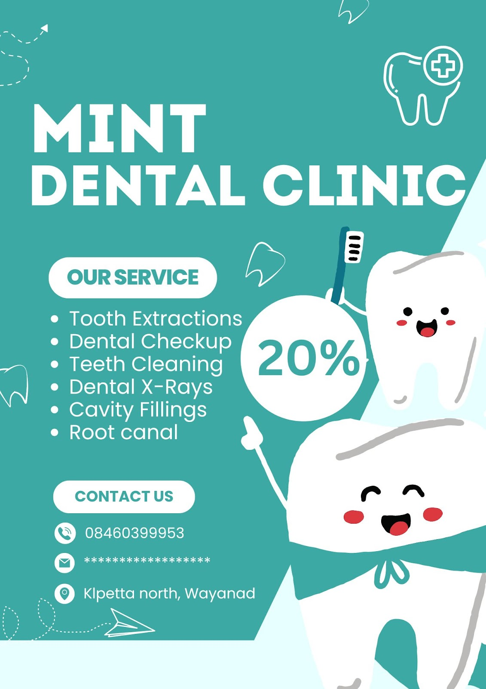

**Conclusion**

By leveraging Google Ads and social media platforms, Mint Specialty Dental Clinic can effectively reach a wider local audience, enhance patient engagement, and drive more appointments. Through continuous monitoring and optimization, we will ensure the best ROI and deliver measurable success for the clinic.